**MINI PROJECT**

**Project :** Generate Random Pasword

**Submitted To :** Pavithra VG

**Submitted By :** Thuyamani kumarakrishna B

**Co-ordinator Name :** Pavithra VG

**Institute Name :** Besant Technologies

**Date :** July 14

**ACKNOWLEDGEMENT**

I would like to express my heartfelt gratitude to **Besant Technologies** for giving me the opportunity to undertake this mini project titled “ Random Technogies “.

I extend my special thanks to my trainer, **[Gowthami]**, for their insightful suggestions, continuous supervision, and for sharing their expertise which has been instrumental in successfully completing this project.

I extend my special thanks to My co ordinator,[**Pavithira**],for their help is successfully complting this project. We are greatly thankful to our Mohamed Ismail Assisstant manager/HR who has been the motivating force behind all our deeds.

I would also like to thank my fellow learners for their cooperation and for creating a collaborative environment that made the learning process enjoyable and enriching.

Finally, I am grateful to my family and friends for their unwavering support and encouragement throughout my learning journey.

|  |  |  |
| --- | --- | --- |
| **Serial No** | **Table of contents** | **Page No** |
| 1 | Concept Used in project | 4 |
| 2 | Source code | 5 |
| 3 | Description of Source code | 6 |
| 4 | Output | 7 |
| 5 | Conclusion | 8 |
| 6 | Biliography | 9 |

**Concept Used in Project**

**Random Module**

Used to generate random character (letter,digits,symbols) for the password.

Function like random.sample()

**String Module**

Provide predefined sets of characters such as string.ascii_lowercase, string.ascii_uppercase, string.digits and string.punctuation to make password creation easier.

**String Join Method(“.join())**

Convert a list of characters into a single string password.

**Source code**

import random

import string

print("Random Password generator")

print("________________________________")

print()

length=int(input("Enter the length of password = "))

lower = string.ascii_lowercase

upper = string.ascii_uppercase

number = string.digits

symbol = string.punctuation

all = lower+upper+number+symbol

temp = random.sample(all,length)

password = " ".join(temp)

print()

print("Your Password is : ",password)

print("________________________________")

**Description of Source Code**

**Code Explanation :**

To generate random password using python, first we have to import the required modules that are **random** and **string**. In **Random module**, The random module in Python is used to generate random numbers and perform random operations, such as selecting random elements from a sequence, shuffling data, or generating random samples. It's commonly used in applications like simulations, games, testing, and statistical sampling.

Another module is **string** module. The string module in Python provides a collection of useful constants and functions that are commonly used for string manipulation and formatting. While many string operations can be done using built-in string methods, the string module offers tools that make certain tasks more convenient and readable.

Next we create the required variable used to store data storing purpose. Following variables are used in this code.

➢ **Lowercase and Uppercase**

In any password that contains both lowercase and uppercase letters, these variables are used to store lower case and uppercase letters respectively that are used in program. In ascii.lowercase/uppercase used to pick the lowercase and uppercase respecticvely.

➢ **Symbol** and digi variables are used to store symbols and numbers.

➢ Then in **all** section we have to concatenate all variable’s values.

➢ Then we create a variable as **length**, which is used to specify the length of the password.

➢ After that we have to **join** all values for generation of password using join method.

➢ Then print the Generated Random Password

**Output**

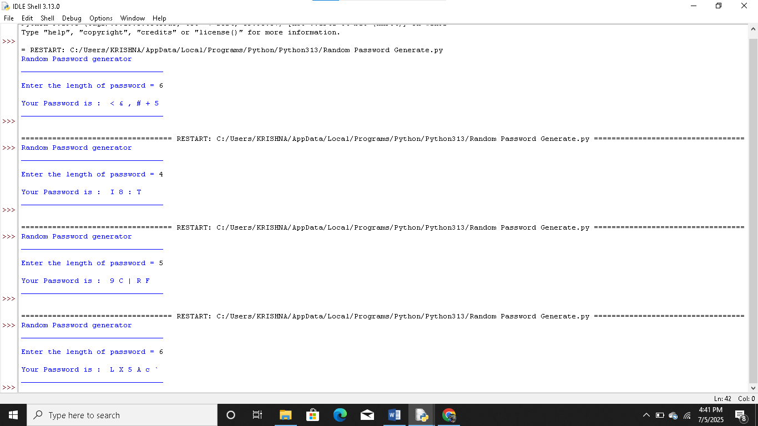

**Conclusion**

This Python mini project successfully generates random and secure passwords of user-defined length. It demonstrates the use of Python’s built-in modules and is useful for enhancing password security in real-world applications.

**Biblography**

1.Python Documentation – <https://docs.python.org/3/>

2. W3Schools Python Tutorial – <https://www.w3schools.com/python/>

3. GeeksforGeeks Python Programming – <https://www.geeksforgeeks.org/python-programming-language/>

4. Programiz Python Guide – <https://www.programiz.com/python-programming>

5.Python class Notes.